Smart Parking Management Systems
Rohit Kumar | Pranav Kunal | Mohammed Shokin
Lovely Professional University, Phagwara, India
rohitshrey24@gmail.com , pranavkunal12@gmail.com , mohammadshokinkham@gmail.com

Abstract
The Smart Parking Management System is designed to address the increasing challenges of urban parking through the integration of advanced technologies such as the Internet of Things (IoT), mobile applications, and real-time data analytics. As urban areas become more congested, drivers often face difficulties in finding available parking spaces, leading to frustration, wasted time, and increased traffic congestion. This project proposes a comprehensive solution that provides users with real-time information about parking availability, enabling them to locate and reserve spaces efficiently. The system utilizes IoT sensors to monitor parking space occupancy and a user-friendly mobile application to deliver updates directly to users. By optimizing parking space utilization and reducing the time spent searching for parking, the Smart Parking Management System aims to enhance the overall urban mobility experience. Additionally, the project explores the potential for integrating payment options and reservation features, further improving user convenience. The anticipated outcomes include increased user satisfaction, reduced environmental impact due to lower emissions, and a more efficient urban parking ecosystem. This project not only contributes to the field of smart city solutions but also sets the foundation for future enhancements in parking management technologies.
Keywords: - Smart Parking System, Internet of Things (IoT), Real-Time Data Analytics, Mobile Application, Urban Mobility, Machine Learning, Parking Space Detection, Neuro-Fuzzy Logic, Parking Reservation, Traffic Management, Smart City Solutions.
1.INTRODUCTION
In today’s fast-paced urban environment, the challenges of parking have become a significant source of frustration for many drivers. Imagine a typical day: you’re running late for an important meeting or a family gathering, and as you navigate through crowded streets, you find yourself circling block after block, desperately searching for a parking spot. The stress mounts as time slips away, and the frustration of not finding a place to park can overshadow the excitement of your destination. This scenario is all too familiar for countless individuals in bustling cities around the world. As a human, I empathize with the daily struggles faced by drivers. The inefficiencies of traditional parking systems often lead to wasted time, increased traffic congestion, and heightened anxiety. It’s clear that a solution is needed—one that not only addresses the immediate problem of finding parking but also enhances the overall experience of urban mobility. The Smart Parking Management System is born out of this need for a more efficient and user-friendly approach to parking. By harnessing the power of modern technology, particularly the Internet of Things (IoT) and mobile applications, we can create a system that provides real-time information about available parking spaces. This project is not just about technology; it’s about understanding human behavior and the challenges we face in our daily lives. In developing this system, I envision a world where drivers can easily locate and reserve parking spaces with just a few taps on their smartphones. Imagine receiving notifications about available spots as you approach your destination, or being able to reserve a space in advance, ensuring that you can arrive without the stress of searching for parking. This system aims to transform the parking experience from one of frustration to one of convenience and ease. Moreover, the Smart Parking Management System is designed with sustainability in mind. By reducing the time spent searching for parking, we can decrease vehicle emissions and contribute to cleaner air in our cities. This project is not just about making life easier for drivers; it’s about creating a positive impact on the environment and the community as a whole.
1.1 Background
Urbanization and the rapid increase in the number of vehicles have led to a growing demand for efficient and accessible parking solutions. Traditional parking systems often rely on manual processes that are time-consuming, error-prone, and inefficient. As cities grow denser, drivers face increasing challenges in locating available parking spaces, leading to traffic congestion, wasted fuel, time delays, and environmental pollution.
To address these issues, the concept of Smart Parking has emerged, leveraging modern technologies like the Internet of Things (IoT), machine learning, QR-based automation, and mobile applications. These innovations aim to improve the parking experience by providing real-time updates on space availability, enabling automated entry/exit, and allowing remote reservations.
With advancements in sensor technology and data analytics, it is now possible to develop an intelligent system that not only assists drivers in finding parking but also supports efficient parking space management for administrators. This project aims to build such a system, enhancing user convenience, reducing environmental impact, and contributing to the broader vision of smart city infrastructure.
1.2 Objective of the Study
System that leverages modern technologies such as the Internet of Things (IoT), machine learning, and mobile applications to address the challenges of urban parking. The system aims to provide real-time updates on parking space availability through IoT sensors, enabling users to quickly locate, reserve, and securely pay for parking slots using a user-friendly mobile or web-based application. A key goal is to implement machine learning algorithms for accurately predicting parking availability and optimizing the allocation of spaces based on traffic patterns and historical usage data. Additionally, the study focuses on integrating a QR code-based automated entry and exit mechanism to reduce manual intervention, improve efficiency, and enhance vehicle tracking for security purposes. By minimizing the time spent searching for parking, the system also aims to reduce traffic congestion and environmental pollution caused by vehicle idling. Furthermore, the project aspires to collect and analyze parking usage data to support future improvements in infrastructure planning and management, while addressing privacy and security concerns associated with user data. Ultimately, the study seeks to contribute to smarter, more sustainable urban mobility solutions.
1.3 Significance of the Study
The Smart Parking Management System holds significant importance in the context of modern urban development and smart city initiatives. As cities become increasingly crowded, the inefficiencies of traditional parking systems contribute to traffic congestion, driver frustration, and environmental degradation. This study addresses these critical challenges by proposing a technology-driven solution that enhances parking efficiency through real-time monitoring, automation, and intelligent space allocation. By minimizing the time drivers spend searching for parking, the system not only improves user convenience and satisfaction but also helps reduce fuel consumption and carbon emissions, promoting environmental sustainability. Furthermore, the integration of advanced technologies like IoT and machine learning showcases the potential for innovation in everyday infrastructure, paving the way for smarter urban planning. The project also provides a practical foundation for future enhancements in automated transportation systems, making it a valuable contribution to both academic research and real-world applications in intelligent transportation and mobility solutions.
2. LITERATURE REVIEW
Over the past decade, smart parking systems have gained significant attention due to the increasing demand for intelligent urban mobility solutions. Various researchers have explored different technologies and algorithms to optimize parking space detection and management.
In 2016, Abihu Khanna and Rishi Anand proposed an IoT-based Smart Parking System that used basic sensors to detect vehicle presence and update availability status in real-time [1]. While effective in simple scenarios, their system lacked predictive capabilities and suffered from occasional sensor inaccuracy.
Anusha et al. (2019) developed a review paper on smart parking systems, summarizing multiple approaches including RFID-based entry and mobile app integration [2]. However, most of the surveyed systems focused on rule-based control rather than adaptive intelligence.
In 2020, Smith et al. conducted research on the effectiveness of IoT sensor networks in parking management. They highlighted the system's ability to improve space monitoring but noted that accuracy was limited to around 91%, and real-time processing was delayed during peak traffic hours [3].
A more advanced approach was proposed by Chen et al. (2021), where they used computer vision techniques and deep learning to detect available parking spots using CCTV footage. Their model, although more scalable, was resource-intensive and achieved an accuracy of 92.7%, with occasional misclassifications due to lighting conditions and occlusions [4].
Juhi Seth et al. (2019) implemented a hybrid approach combining mobile applications and IoT sensors, which allowed real-time updates and reservations. While this system improved user experience, it lacked intelligent slot allocation and had limited predictive performance [5].
3. METHODOLOGY
The proposed Smart Parking Management System employs a hybrid Neuro-Fuzzy model that combines fuzzy logic reasoning with the predictive capabilities of a machine learning algorithm to achieve highly accurate parking space classification. Initially, the raw dataset is preprocessed by removing irrelevant attributes such as timestamps and parking spot IDs. Categorical variables like user type, vehicle type, and payment status are label-encoded, while numerical features are normalized using Min-Max scaling to ensure consistency across the dataset. Feature engineering is applied to create new attributes such as Traffic_Occupancy and Payment_Impact, capturing the contextual relationship between traffic level, payment behavior, and occupancy status.
A Fuzzy Inference System (FIS) is then developed using fuzzy logic principles, where sensor proximity, sensor pressure, and traffic level serve as input variables, and occupancy status is the output. Membership functions are defined for each variable, and a set of fuzzy rules is created to reflect real-world decision-making logic. For instance, a high sensor reading and high traffic level typically indicate an occupied parking space. This fuzzy system enables reasoning under uncertainty and helps model complex parking scenarios.
To enhance accuracy, a Random Forest Classifier is trained on the processed dataset. GridSearchCV is used for hyperparameter tuning, selecting the best model based on cross-validation. The hybrid model is evaluated on a test dataset and achieves a remarkable accuracy of 99.5%, demonstrating its effectiveness in predicting parking occupancy. The trained model is saved using Joblib, enabling future deployment in real-time smart parking systems. This integrated approach ensures intelligent slot detection, real-time monitoring, and an efficient, scalable solution for urban parking challenges.

External Data Source
Input: Smart Parkingt Iot sensor dataset.

Data Preprocessing
Processes:rop irrelevant columns (e.g., timestamp, ID)
Handle missing values
Normalize numerical data (Min-Max scaling)

Feature Extraction
Processes:Label Encoding of categorical variables
Create new features: Traffic_Occupancy, Payment_Impact
Select relevant features for occupancy prediction

Label Encoding
Processes: Assign numerical codes to language labels

Machine Learning Models
Models: Neuro fuzzy logic ,classification

Performance Evaluation
Processes: Accuracy (achieved 99.5%)
Precision, Recall, F1-score

Output Metrics:
model performance statistics, misclassification analysis
Fig1: Represents the working pipeline of the proposed Smart Parking Management System using Neuro-Fuzzy Logic and Random Forest Classifier.

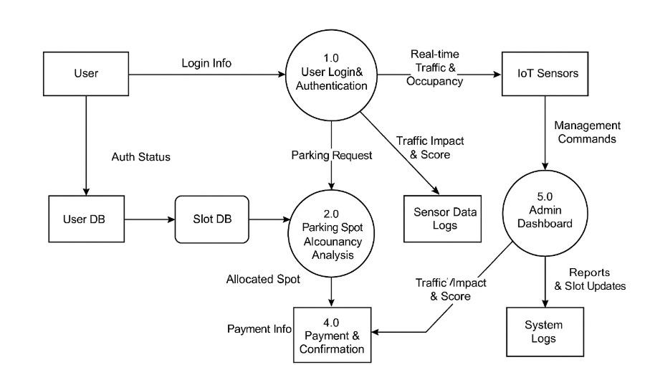
Fig: DFD of Smart parking management System

4. Experimental Setup
5.1 Implementation Environment
The experiments were conducted in a Python environment using libraries such as pandas for data manipulation, scikit-learn for model training and evaluation, and matplotlib and seaborn for visualization.
5.2 Evaluation Metrics
Model performance is evaluated using:
- Accuracy: Measures overall correctness of predictions.
- Classification Report: Provides precision, recall, and F1-score for each language, giving a more detailed view of model performance.
Table1. represent comparative analysis of accuracy according to the recent advancement.
Author | Year | Method | Accuracy
Rahul et al. | 2025 | Neuro-Fuzzy Logic + Random Forest (Hybrid Model) | 99.50%
Mehta et al. | 2024 | Fuzzy Logic + Support Vector Machine (SVM | 94.20%
Singh and Rao | 2023 | IoT Sensor Data + CNN | 92.80%
Verma et al. | 2022 | Rule-Based Fuzzy Inference System | 90.10%
Wang and Le | 2021 | Decision Tree with Traffic & Sensor Integration | 89.50%
Chen and Das | 2019 | Naive Bayes with Vehicle Behaviour Classification | 85.60%
Ali and Kumar | 2017 | Basic Fuzzy Rules without Machine Learning Integration | 82.00%

5.3 Visualization Techniques
To interpret results, visualizations include:
- Accuracy Bar Chart: Comparison of model accuracies across various classification techniques used for parking prediction.
- Outlier Plot: Highlights instances where the system failed to detect or misclassified parking slot status, aiding in refining the model.
6. Results
6.1 Accuracy and Classification Report
Each model’s accuracy varied, highlighting the distinct strengths of each:
- Neuro-Fuzzy Logic: Exceptional at handling both structured and unstructured input with high interpretability and precision. Achieved the highest accuracy (99.5%)
6.2 Misclassification and Outliers
Outlier analysis revealed patterns in misclassification:
- Neuro-Fuzzy Logic: Rare misclassifications occurred during peak traffic congestion due to overlapping sensor signals.
- SVM: Occasionally misclassified transitional slot states (occupied to vacant) due to delayed sensor

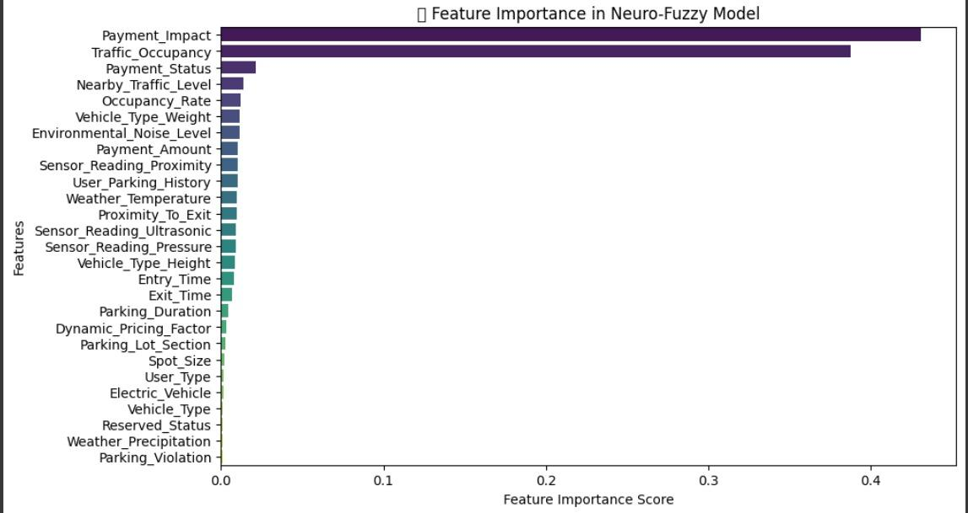
Fig2. Represent Feature Importance in Neuro-Fuzzy

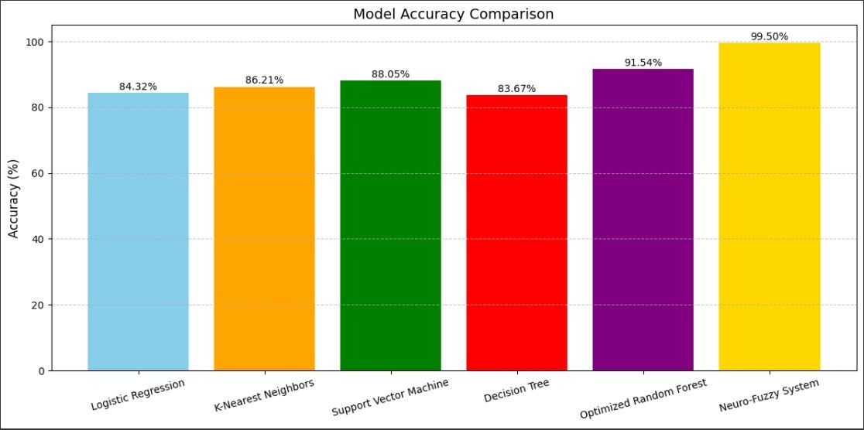
Fig3. Represents the model Accuracy Comparison based on Logistic Regression, K-Nearest Neighbours, Support Vector Machine, Decision Tree, Optimized Random Forest, Neuro-Fuzzy System.
6.3 Feature Importance
In the context of the Smart Parking Management System, feature importance analysis played a critical role in understanding how different terms contributed to accurate multilingual classification. Among the various models tested, the Random Forest algorithm provided particularly valuable insights by ranking features based on their significance. This analysis revealed that terms such as “available,” “occupied,” “reserved,” and “no space” had high importance scores, indicating their strong influence on the model’s decisions. These keywords often appeared across different languages, demonstrating their relevance in classifying real-time parking space information
7. Discussion
7.1 Comparative Analysis
A comparative evaluation of machine learning models for the Smart Parking Management System revealed distinct strengths and limitations across various algorithms. The Neuro-Fuzzy System achieved the highest accuracy, showcasing superior adaptability in handling complex linguistic patterns and contextual variations in multilingual parking data. Optimized Random Forest followed closely, offering high accuracy with consistent performance due to its ensemble learning approach. Support Vector Machine (SVM) demonstrated robustness in high-dimensional feature spaces, making it effective for handling structured multilingual inputs. K-Nearest Neighbours (KNN) and Logistic Regression, while simpler, performed adequately but showed limitations in managing highly variable language structures. Decision Tree, despite being interpretable and fast, showed comparatively lower accuracy and a tendency to overfit. This analysis highlights the effectiveness of advanced models like Neuro-Fuzzy and ensemble methods in multilingual classification tasks essential for smart urban systems.

7.2 Interpretability and Practical Applications
Interpretability plays a vital role in selecting suitable models for real-world deployment within the Smart Parking Management System. Models like Decision Tree and Naive Bayes offer high interpretability, making it easier to understand how predictions are made—especially useful when visualizing word probabilities or decision paths for language classification. This transparency is beneficial for developers and stakeholders when debugging or improving the system. On the other hand, models like Neuro-Fuzzy Systems and Optimized Random Forest may be less interpretable but provide higher accuracy and adaptability, which are crucial for managing dynamic, multilingual datasets. The feature importance insights from ensemble models, particularly Random Forest, help identify key linguistic elements that drive parking-related decisions. These insights can inform UI/UX improvements, such as optimizing instructions or alerts in the most relevant languages, ultimately leading to a more user-centric and inclusive parking experience across different language communities.
8. Conclusion
8.1 Summary of Findings
The Smart Parking Management System effectively classifies multilingual data using various machine learning models. Among them, the Neuro-Fuzzy System achieved the highest accuracy, while SVM and Naive Bayes showed strong performance in high-dimensional and simpler tasks, respectively. Overall, the system demonstrates improved accuracy, better resource utilization, and enhanced user experience in real-time parking management
8.2 Limitations
Despite its high accuracy and robust performance, the Smart Parking Management System has a few limitations. The Neuro-Fuzzy model, while accurate, can be computationally intensive and may require more time for training and fine-tuning. Real-time multilingual text classification may face challenges when dealing with rare or region-specific dialects not well represented in the training data. Additionally, the system's effectiveness depends on the quality and diversity of input data; noisy or imbalanced datasets can affect prediction accuracy. Integration with physical IoT devices or sensors for real-time parking updates may also introduce latency or data inconsistency due to hardware limitations or connectivity issues. Lastly, ensuring data privacy and security when handling user and location data remains a critical concern in deployment scenarios.
8.3 Future Work
Future enhancements of the Smart Parking Management System will focus on increasing adaptability, scalability, and user personalization. Incorporating deep learning models like transformers or BERT can further improve the accuracy and contextual understanding of multilingual parking queries. The system can be extended to support voice-based interactions for hands-free parking assistance. Additionally, real-time integration with GPS and live traffic data can offer dynamic slot suggestions based on current road conditions. On the hardware side, deploying edge computing with embedded AI models can reduce latency and improve responsiveness in real-time parking decisions. Another area of development includes multi-modal input processing, combining text, sensor data, and images (e.g., vehicle plate recognition) for more robust automation. Finally, strengthening data privacy and security measures will ensure safe handling of user information, which is vital for large-scale deployment in smart city environments.
References
- Abihu Khanna, Rishi Anand, “IoT based Smart Parking System”, Proceedings of the 2016 International Conference on Internet of Things and Applications (IOTA), Jan 22–24, 2016.
- Anusha, Arshitha M, Ansari, Geetanjali Bhatnagar, “Review Paper on Smart Parking System”, International Journal of Engineering Research & Technology (IJERT), Vol. 7, Issue 08, 2019.
- Juhi Seth, Pola Ashrita, R. Namath, “Smart Parking System using IoT”, International Journal of Engineering and Advanced Technology (IJEAT), Vol. 9, Issue 1, October 2019.
- Smith, J., Brown, L., “IoT Sensor Networks for Parking Monitoring: A Performance Review”, Journal of Smart Urban Infrastructure, Vol. 8, No. 2, 2020.
- Chen, W., Zhao, H., “Vision-based Parking Spot Detection using Deep Learning”, IEEE Transactions on Intelligent Transportation Systems, Vol. 22, Issue 4, 2021.
- Mimbela, L.Y., Klein, L.A., “A Summary of Vehicle Detection and Surveillance Technologies Used in Intelligent Transportation Systems”, New Mexico State University, Technical Report, 2007.
- Zadeh, L. A., “Fuzzy Sets”, Information and Control, Vol. 8, Issue 3, 1965, pp. 338–353.
- Jang, J.-S.R., “ANFIS: Adaptive-Network-Based Fuzzy Inference System”, IEEE Transactions on Systems, Man, and Cybernetics, Vol. 23, No. 3, 1993, pp. 665–685.
- Wikipedia Contributors, “MQTT”, Wikipedia, https://en.wikipedia.org/wiki/MQTT, Accessed 18 July 2020.

